CLADUSS

**A PROJECT REPORT**

**Submitted By Chhavi Choudhary 2100290140054**

**Lov Dubey 2100290140083**

**Amit Kumar Dubey 2100290140023**

**Dipanshu 2100290140061**

**Submitted in partial fulfilment of the Requirements for the Degree of**

MASTER OF COMPUTER APPLICATION

**Under the Supervision of Mr. Ankit Verma**

**Submitted to**

**DEPARTMENT OF COMPUTER APPLICATIONS**

**KIET Group of Institutions, Ghaziabad Uttar Pradesh-201206**

**(FEB 2023)**

# CERTIFICATE

Certified that **Chhavi Choudhary 2100290140054, Lov Dubey 2100290140083, Amit Kumar Dubey 2100290140023, Dipanshu 2100290140061** has/ have carried out the project work having “CLADUSS” for Master of Computer Applications from Dr.

A.P.J. Abdul Kalam Technical University (AKTU**)** (formerly UPTU), Technical University, Lucknow under my supervision. The project report embodies original work, and studies are carried out by the student himself / herself and the contents of the project report do not form the basis for the award of any other degree to the candidate or to anybody else from this or any other University/Institution.

## Date:

**Chhavi Choudhary (2100290140054)**

**Lov Dubey (2100290140083)**

**Amit Kumar Dubey (2100290140023) Dipanshu (2100290140061)**

This is to certify that the above statement made by the candidate is correct to the best of my knowledge.

Date:

## Mr. Ankit Verma Assistant Professor

**Department of Computer Applications KIET Group of Institutions, Ghaziabad**

## Signature of Internal Examiner Signature of External Examiner

**Dr. Arun Tripathi**

**Head, Department of Computer Applications KIET Group of Institutions,**

# ABSTRACT

The CLADUSS is a web-based application intended for online retailers, so that they can buy and sell old products.

The main objective of this application is to make it interactive and its ease of use. It would make searching, viewing and selection of a product easier.

It contains a sophisticated search engine for users to search for products specific to their needs. The search engine provides an easy and convenient way to search for products where a user can Search for a product interactively and the search engine would refine the products available based on the user’s input.

The user can then view the complete specification of each product. They can also view the product reviews and also write their own reviews.

The main emphasis lies in providing a user-friendly search engine for effectively showing the desired results.

# ACKNOWLEDGEMENTS

Success in life is never attained single handedly. My deepest gratitude goes to my thesis supervisor, **Mr. Ankit Verma** for his guidance, help and encouragement throughout my research work. Their enlightening ideas, comments, and suggestions.

Words are not enough to express my gratitude to Dr. Arun Kumar Tripathi Sir, Professor and Head, Department of Computer Applications, for his insightful comments and administrative help at various occasions.

Fortunately, I have many understanding friends, who have helped me a lot on many critical conditions.

Finally, my sincere thanks go to my family members and all those who have directly and indirectly provided me moral support and other kind of help. Without their support, completion of this work would not have been possible in time. They keep my life filled with enjoyment and happiness.

**Chhavi Choudhary (2100290140054)**

**Lov Dubey (2100290140083)**

**Amit Kumar Dubey (2100290140023) Dipanshu (2100290140061)**

# TABLE OF CONTENTS

|  |  |  |  |
| --- | --- | --- | --- |
| Certificate | | | i |
|  | Abstract | | ii |
|  | Acknowledgements | | iii |
|  | Table of Contents | | iv |
|  | List of Abbreviations | | vi |
|  | List of Figures | | vii-viii |
| 1 | Gathering and Analyzing Information | | 1-3 |
|  | 1.1 | Introduction | 1 |
|  | 1.2 | Project Scope | 1 |
|  | 1.3 | Hardware/Software used in a Project | 2 |
|  | 1.4 | Functional Requirement | 2 |
|  | 1.5 | Non-Functional Requirement | 3 |
| 2 | Literature Review | | 4-9 |
| 3 | Feasibility Study | | 10-12 |
|  | 3.1 | Technical Feasibility | 10 |
|  | 3.2 Operational Feasibility | | 10 |
|  | 3.3 Behavioral Feasibility | | 11 |
|  | 3.4 Economical Feasibility | | 13 |
| 4 | Database Design | | 14-22 |
|  | 4.1 Flow Chart Diagram | | 13 |
|  | 4.2 Data Flow Chart Diagram | | 16 |
|  | 4.3 Entity Relationship Diagram | | 19 |
|  | 4.4 Use Case Diagram | | 21 |
|  | 4.5 Sequence Diagram | | 22 |
| 5 | Form Design | | 23-27 |
|  | 5.1 Landing Page | | 23 |
|  | 5.2 Login Page | | 24 |

|  |  |  |
| --- | --- | --- |
|  | 5.3 Products Page | 25 |
|  | 5.4 Add Product Page | 26 |
|  | 5.5 Cart Page | 27 |
| 6 | Testing | 28- |
|  | 6.1 Login | 30 |
|  | 6.2 Add Products | 29 |
|  | 6.3 Cart | 32 |
|  | 6.4 Placed/Modify | 35 |
|  | 6.5 Logout | 38 |
| 7 | Bibliography | 39 |

**LIST OF ABBREVIATIONS**

|  |  |  |  |
| --- | --- | --- | --- |
| **S No.** | **Name of Abbreviations** | **Details of Abbreviations** | **Page** |
| 1 | CS | Computer Science | 2 |
| 2 | OS | Operating System | 2 |
| 3 | UPS | Universal Power Supply | 10 |
| 4 | MS WORD | Microsoft Word | 11 |
| 5 | DFD | Data Flow Diagram | 16 |
| 6 | ER | Entity Relationship Diagram | 19 |
| 7 | UCD | Use Case Diagram | 21 |
| 8 | SD | Sequence Diagram | 22 |
| 9 | UML | Unified Modeling Language | 22 |

# LIST OF FIGURES

|  |  |  |
| --- | --- | --- |
| **Figure No.** | **Name of Figure** | **Page No.** |
| 4.1 | Flow Chart Symbols | 14 |
| 4.2 | Flow Chart Diagram | 15 |
| 4.3 | Data Flow Symbols | 16 |
| 4.4 | Level 0 DFD | 17 |
| 4.5 | Level 1 DFD | 17 |
| 4.6 | Level 2 DFD (3.0), (4.0) and (5.0) | 18-19 |
| 4.7 | Entity Relationship Diagram | 20 |
| 4.8 | Use Case Diagram | 21 |
| 4.9 | Sequence Diagram | 22 |
| 5.1 | Landing Page | 23 |
| 5.2 | Login Page | 24 |
| 5.3 | Product Page | 25 |
| 5.4 | Add Product Page | 26 |
| 5.4 | Cart Page | 27 |
| 6.1 | Login Page Interface | 28 |
| 6.2 | Login Page Authentication | 28 |
| 6.3 | Login Page Verified User | 29 |
| 6.4 | Products Page Interface | 30 |
| 6.5 | Add Product Page Interface | 30 |
| 6.6 | Product Adding Page Interface | 31 |
| 6.7 | Product Added Successfully Page Interface | 31 |
| 6.8 | Cart Page Interface | 32 |
| 6.9 | Adding Product to Cart Page Interface | 32 |
| 6.10 | T.V Added Successfully Page Interface | 33 |
| 6.11 | Earphone Added Successfully Page Interface | 33 |
| 6.12 | T.V and Earphone Added to Cart Page Interface | 34 |

|  |  |  |
| --- | --- | --- |
| 6.13 | Adding 1 more T.V to Cart Page Interface | 35 |
| 6.14 | Adding 1 more Earphone to Cart Page Interface | 35 |
| 6.15 | Product Modifications Successful Page Interface | 36 |
| 6.16 | Products Removing Page Interface | 36 |
| 6.17 | Products Removed Successful Page Interface | 37 |
| 6.18 | Logout Successful Page Interface | 38 |

**CHAPTER 1**

**GATHERING AND ANALYSING INFORMATION**

## INTRODUCTION

This project has been developed to override the problems prevailing in the practicing manual system. This application is supported to eliminate and,in some cases, reduce the hardships faced by the existing system. Moreover,this application is designed for moving toward the secure digitalization. It willenhance the transparency in the work.

CLADUSS is an online website for buy and sell in which the specific knowledge of the product is given as a description. If the product is uploaded on the website, then it is available for the people who are willing to buy.

The two features of this website are – Selling and Buying goods where the product description will be related to product and its features. It will be related to the properties of the product (for ex- Material used, Easy to wash, Water proof or not).

The user will be able to upload a product to sell only if he completes the criteria of at least 4 photos of the product and a minimum of 50 words description. On our website the sellers can store the Product name & photos selling price on which he wants the product to be sold to make the buying easier. It has been divided into two categories, one is descriptions of product and other is buying and payment mode.

The “CLADUSS” has been developed to override the problem of today’s common problem to buy or sell an old product. The whole project is designed in a way to make it user friendly, so that the person having just basic knowledge of the computer can easily use the website and buy or sell their product.

## PROJECT SCOPE

The main purpose of the project on Claduss was to reduce paper work and support digitalization. It may help collecting perfect management in detail. In a noticeable short time, collection will be obvious, simple, and sensible. It will help a person to know the management of passed records perfectly and vividly.

This system can be implemented in the locality of KIET Group of Institutions. The system recommends a facility to accept the orders 24*7 and a customer verification system by which the customer can view the products before buying and get fully satisfied before buying which can make customers happy.

The CLADUSS is providing an online portal where their customers can enjoy easy shopping from anywhere, this website won’t be losing any more customers to the trending

online shops such as OLX or eBay. Since the application is available in the Web form and it is easily accessible and always available. Our project aims at Business process automation, i.e., we have tried to computerize various processes of Inventory Management.

* + - In CS, it is not necessary to create the manifest, but we can directly print it which saves our time.
    - To assist the staff in capturing the effort spent on their respective working areas.
    - To utilize resources in an efficient manner by increasing their productivity through automation.
    - Be easy to operate.
    - It satisfies the user requirement
    - Have a good user interface
    - Be expandable
    - Manage the information of cost
    - Editing and updating of records is improved which results in proper resource management.

## HARDWARE / SOFTWARE USED IN A PROJECT

* + 1. **Software Requirements**
    - **OS -** Windows 7,8,10,11
    - **Language –** ASP Dot Net (C#)
    - **Platform -** Web Browser

## Hardware Requirements

* + - **Processor –** Dual Core and above
    - **RAM –** 512 MB
    - **Storage –** 20 GB
    - **Monitor –** 15” Color Monitor
    - **Keyboard –** 122 keys

## FUNCTIONAL REQUIREMENTS Ordering System

* + - Create an Account
    - Login to the Website
    - Navigate to the Claduss menu
    - Select an item from the menu
    - Customized options for selected items
    - Add item to current order
    - Remove items/ remove all items from current order

## Menu Management System

* + - Add a new/update/delete vendor to/from the menu
    - Add a new/update/delete products category to/from the men
    - Add a new/update/delete product item to/from the menu
    - Add a new/update/delete option for a given product item.
    - Update price for a given products item
    - Update additional information for a given products item

## Order Retrieval System

* + - Retrieve new orders from the Ms base
    - Display the orders in an easily readable, graphical way
    - Mark an order as having been processed and remove it from the list of active orders.

## NON- FUNCTIONAL REQUIREMENTS

* + - **Portability**

System running on one platform can easily be converted to run on another platform.

## Reliability

The ability of the system to behave consistently in a user-acceptable manner when operating within the environment for which the system was intended.

## Availability

The system should be available at all times, meaning the user can access it using a web browser, only restricted by the down time of the server on which the system runs.

## Maintainability

A commercial database is used for maintaining the database and the application server takes care of the site.

## Security

Secure access of confidential data.

**CHAPTER 2**

**Literature Review**

## Introduction

E-commerce is a boom in the modern business. E-commerce means electronic commerce. E-commerce involves buying and selling of goods and services, or the transmitting of funds or data, over an electronic data, predominantly the Internet.

Online shopping is a platform where users can fulfil requirements regarding their shopping completely. The goal of the website is to provide complete shop in a precisely and to the point. Shopping material is in very basic shop so that user can understand it so well. The theme of the website is to help the people to encourage their shop and the shopping deeply with the help of graph and images. On this website contents are on well- structured way so that the user understand the subjects in a very less time.

## Abstract

Online shopping is the process whereby consumers directly buy goods or services from a seller in real time, without an intermediary service, over the Internet. It is a form of electronic commerce. This project is an attempt to provide the advantages of online shopping to customers of a real shop. It helps buying the products in the shop anywhere through internet by using an android device.

The central concept of the application is to allow the customer to shop virtually using the internet and allow customers to buy the items and articles of their desire from the store. The information pertaining to the products are store on the RDBMS at the server side.

The application was designed into two modules first is for the customers who wish to buy the items. Second is for the storekeepers or seller who wish to sell their products online, maintains and updates the information pertaining to the article and those of the customers.

## Literature Review

In recent years, online buying and selling have become increasingly popular due to the convenience and accessibility it offers. With the growth of e-commerce platforms and

the increasing use of mobile devices, more people are turning to online marketplaces for their shopping needs. This paper examines the various aspects of online buying and

selling, including consumer behaviour, e-commerce platforms, security and privacy, mobile commerce, payment systems, and customer service. As the status and usage of the Internet continues to grow, the security and privacy of online transactions bring to light the necessity for trust; however, lack of trust is regarded as the greatest barrier preventing consumers from transacting online [1].

Consumer behavior plays a significant role in online buying and selling. Online shoppers have different needs and preferences than those who shop in physical stores. Factors such as trust, convenience, and pricing influence consumer behavior in online marketplaces. Trust is particularly important, as consumers need to feel confident that the seller is reliable and will deliver the product as described. Convenience is another important factor, as consumers expect fast and efficient transactions. Finally, pricing is also critical, as consumers can easily compare prices across different online stores. With the development of internet of things, the online exchange of used goods among consumers, that is C2C exchanges have been greatly facilitated. The buyers and sellers remain anonymous to each other in C2C exchanges until the time of final deal [2].

There are different types of e-commerce platforms available for online buying and

selling. B2B (business-to-business), B2C (business-to-consumer), and C2C (consumer- to-consumer) are the most common. B2B platforms connect businesses with other businesses, while B2C platforms connect businesses with individual consumers. C2C platforms, on the other hand, allow individuals to buy and sell goods and services with each other. Each type of platform has its strengths and weaknesses, and it's important to choose the right one depending on the business model.

There are many factors related to online service providers that affect consumers’ perception towards them and the subsequent attitude formation. One of them is online security. Positive customer experiences on the security aspect provided by online e-

tailers lead to formation of a positive security perception and subsequent attitude formation towards the same [3][4].

Buying goods and services via ECommerce allows consumers the freedom to choose when and where to shop and the opportunity to research the product, the seller, and any other available options. Shopping has been revolutionized through the availability of online information. Just about anything that can be bought in a merchandise store can be bought via E-commerce, even perishables like groceries. And consumers have embraced these possibilities around the globe.[5]

E-Commerce has unleashed yet another revolution, which is changing the way businesses buy and sell products and services. New methodologies have evolved. The role of geographic distances in forming business relationships is reduced. E-Commerce is the future of shopping. With the deployment of 3G and 4G wireless communication

technologies, the internet economy will continue to grow robustly. In the next 3 to 5 years, India will have 30 to 70 million internet users which will equal, if not surpass, many of

the developed countries. Internet economy will then become more meaningful in India. With the rapid expansion of internet, Ecommerce is set to play a very important role in the 21st century, the new opportunities that will be thrown open, will be accessible to both large corporations and small companies. The role of government is to provide a legal framework for E-Commerce so that while domestic and international trade are allowed to expand their horizons, basic rights such as privacy, intellectual property, prevention of fraud, consumer protection etc are all taken care of [6].

People have attitude towards anything that gives out a stimulus to the environment whether it is religion, politics, food, music, and other people. Attitude formed through cognitive processes can make people like or dislike objects or ideas prompting them to move towards or away from them [7].

A regular opinion is a sentiment only about a particular target whereas a comparative opinion is a sentiment about multiple targets [8].

Security and privacy are major concerns when it comes to online buying and selling. Fraud, identity theft, and data breaches are some of the risks associated with online transactions. To protect consumers, online marketplaces need to implement security measures such as encryption and two-factor authentication. It's also important for consumers to be vigilant and take steps to protect their personal and financial information. Irrelevant or useless information weakens consumer trust on the online service provider and they perceive the online service provider to be poor in quality [9]. Internet safety is still a concern in India as it is unregulated and there are only a handful of cyberlaws. This leaves E – commerce companies and consumers susceptible to online money frauds. Majority of the customers are not aware of the cyber security breaches due to lack of transparency. Large E - Retailers and E – commerce players are forced to invest millions of dollars to increase efforts towards cyber security, in the absence of policy support and suitable legal remedy. Financial institutions along with the Government must work on cyber laws and implement it effectively to ensure that an Indian customer is safe on the Internet while performing a transaction.

In e-commerce, where the only source of information to overcome uncertainty is the website, trust in the website is of paramount importance because it is one of the most effective methods for reducing consumer uncertainty [10].

In particular, trust in the online environment is important because of the complexity and diversity of online interactions and the resulting possibility of insincere and unpredictable behavior [11].

Businesses are increasingly making use of social media in order to market their goods and services. Social media refers to websites and computer programs that allow people to communicate and share information on the internet using a computer or mobile phone. Social media has played a great role in brand building and informing various offers to the customers. It also helps in getting the feedback about the product or service. It provides a platform for brand building, advertisements, developing a community of trusted users,

spreading word of mouth etc [12].

The purchasing of products and services through e-commerce enables shoppers to select when and where to buy and to study the commodity, the vendor and other choices available. The availability of online information has revolutionized the buying process.

Almost anything that can be purchased in a shop, including perishable items such as food, can be purchased through e-commerce. And customers around the world have taken up these opportunities. In all spheres of industry, from services provides to the customer to the design of the new product, the influence of e-commerce already exists [13].

Ten items contributing to overall consistency in e-commerce customer relationship management. These items are consistency of transaction steps, consistency of Web site design, consistency of navigation, consistency of promotions, consistency of in-stock indications, consistency of product variety, consistency of fraud protection, consistency of product guarantees, consistency of overall site fairness, and consistency of return policies. This list of consistency items includes three usability items. It can be concluded that sites with good usability have a better chance of having successful CRM implementation in their business. Consistency of promotions, in-stock indications, product variety, fraud protection, guarantees, fairness, and return policies indicate mainly that customers in fact demand a high level of security-related information as well as trustworthiness and high ethics on the shopping site to become regular customers of evendors. Customers demand equal and consistent treatment concerning products and productrelated services. The findings indicate that the level of security and guarantees presented to customers has a significant positive effect on customer retention and customer acquisition.

The future of E-Commerce is difficult to predict. There are various segments that would grow in the future like: Travel and Tourism, electronic appliances, hardware products and apparel. There are also some essential factors which will significantly contribute to the boom of the E-Commerce industry in India i.e. replacement guarantee, M-Commerce services, location based services, multiple payment option, right content, shipment option, legal requirement of generating invoices for online transactions, quick Service, T & C should be clear & realistic, the product quality should be same as shown on the portal, dedicated 24/7 customer care centre should be there.

## Conclusion

A developing country may well attempt to be modernized if it introduces e-commerce effectively and efficiently. It will improve its output and lead to its competitive advantage. Information Technology (IT) has uplifted ecommerce worldwide. Now it’s at ease to enter to a new market and marketers’ can easily evaluate their product and company’s performance. A growing number of firms in various industries, such as banking, education, commerce, and tourism, etc. have improved their services by both incorporating technologies into their service delivery process. Integration of technology in services is becoming very common; however, very little academic research has been conducted to examine its influence. The issues related to Ecommerce are also on the rise which is posing serious threat to its tall future and hence demands right strategies on part of marketers.

Online buying and selling offer many benefits, including convenience, accessibility, and a wide range of products and services. However, there are also risks and challenges associated with online transactions, such as security and privacy concerns. It's important for online marketplaces to implement security measures and provide responsive customer service to ensure customer satisfaction. As technology continues to evolve, online buying and selling will likely continue to grow in popularity, and businesses need to stay ahead of the curve to remain competitive.

The research works on E-commerce propose good number of variables to be taken care of if marketers need to be successful in this newly business model. The factors which will significantly contribute to the success of the E-Commerce industry and focused upon should be consistency of transaction steps, consistency of Web site design, replacement guarantee, MCommerce services, consistency of promotions, consistency of in-stock indications, consistency of product variety, location based services, multiple payment option, right content, shipment option, legal requirement of generating invoices for online transactions, quick Service, T & C should be clear & realistic, the product quality should be same as shown on the portal

## References

[1].Lallana, E., Quimbo, R. and Andam, Z. R. (2000). ePrimer: An Introduction to eCommerce. Philippines: DAI-AGILE.

1. Yen, C. a. (2008). Effects of E-Service quality on loyality intention: an emperical study on online auction. Managing service quality: an international Journal
2. Krishnamurthy, S. (2001). A comprehensive analysis of permission marketing. Journal of computer medicated communication, 15.
3. Ha, H. (2004). Factors influencing consumer perception of brand trust online. Journal of product and brand management, 13.
4. International Journal of Commerce and Management Studies (IJCAMS) Vol.5, Issue 1, March 2020
5. Mitra, Abhijit (2013), “e-commerce in India- a review”, International journal of marketing, financial services & management research, vol.2, no. 2, pp. 126-132
6. Keller, K. (2003). Strategic brand management: building, measuring and managing brand equity. Upper Saddle River,12
7. Liu, B. (2012). Sentiment analysis and Opinion Mining. Claypool & Morgan,10.
8. Ha, H. (2004). Factors influencing consumer perception of brand trust online. Journal of product and brand management, 13
9. Yeh, J., (2012). A study of purchasing behavior in Taiwan's online auction website effects of uncertainty and gender difference. International research, 17
10. Gefen, D. (2000). E-commerce: The role of familiarity and trust, Omega 28: 725– 737.

[12]. Rust,R.,T., and Chung,T.,S. (2006) “Marketing Models of Service and Relationships” Marketing science,25.6, pp. 560-580

[13]. P. Kalia, N. Kaur, and T. Singh, “E-Commerce in India,” in Mobile Commerce, 2017.

**CHAPTER 3**

**FEASIBILITY STUDY**

## TECHNICAL FEASIBILITY

This is concerned with specifying equipment and software that will successfully satisfy the user requirement. The system must be evaluated from the technical point of view first. The assessment of this feasibility must be based on an outline design of the system requirements in the terms of input, output, programs and procedures.

On having identified an outline system, the investigation must go on to suggest the type of equipment, required method developing the system, of running the system once it has been designed.

The technical needs of the system may vary considerably but might include:

* + - The facility to produce outputs in given time
    - Response time under output conditions
    - Ability to process a certain volume of at a particular speed
    - Facility to communicate data to distant location
    - Technical feasibility centre on the existing computer system (hardware, software, etc. and to extent it can support the proposed addition.

## OPERATIONAL FEASIBILITY

Proposed project is beneficial only if they can be turned into information. Systems that will meet the operating requirement of the organization. This test of feasibility asks if the system will work when itis developed and installed. It is mainly related to human organization and political aspect.

The points to be considered are:

* + - What changes will be brought with the system?
    - What organizational structures are distributed?
    - What new skill will be required?

Do the existing staff members have these skills? If not, can they be trained in due course of time? Generally, project will not be rejected simply because of operational in feasibility but such consideration is likely critically affecting the nature and scope of the eventual recommendations. The operational feasibility is mainly related to human organizational and political aspects. My project “CLADUSS” is operational feasible due to following reason :-

* + - No existing organizational structures are distributed.
    - Basic knowledge of operational computer will be required for the end users, and it was that personnel of library were familiar with the basic operation of the computer.

Because they had a little knowledge of computers on specifics like MS-Word

etc. so there was only requirement of training to operate this software. It is very easy to train them within a small duration of time.

## BEHAVIORAL FEASIBILITY

Behavioral Feasibility is the measure of how the society is looking towards our project, what is the reaction of people who are going to use this in upcoming future.

It includes how strong the reaction of user will be towards the development of new system that involves computer’s use in their daily life for maintaining digital records of Claduss website.

This includes the following questions :-

* + - Is there sufficient support for the users?
    - Will the proposed system cause harm?

The project would be beneficial because it specifies the objectives when developed and installed. All behavioral aspects are considered carefully and conclude that the project is behaviorally feasible.

## ECONOMICAL FEASIBILITY

Economical is most frequently used technique for evaluating the effectiveness of a proposed system. More commonly known as cost or benefit analysis, the procedure is to determine the benefits and saving that are expected from a proposed system and compare with cost.

It benefits out weight costs a decision taken to design and implement the system. Otherwise, further justification or alternative in the proposed system will have to be made if it is to have a chance of being approved. This is an ongoing effort that improves in accuracy at each phase of the system life cycle.

An evaluation of development cost weighed against the ultimate income of benefit derived from the development system or project among the most important information contained in feasibility study is cost benefit analysisan assessment of the economic justification for a computer-based system project.

The benefits of a project include four types:

* + - Cost saving benefits.
    - Cost avoidances benefits.
    - Improved service level benefits.
    - Improved the information benefits.
    - The cost of the hardware and software.
    - The costs conduct a full system investigation.
    - The benefits in the form of reduced costs or fewer costly errors.

Cost saving benefits of our projects lead to the reduction in administration & operational costs. A cost avoidance benefits our project does not require future and additional staff and also reduces any future operational cost. This project leads the quicker and enhanced administrative decision thus making im proved information benefits.

**CHAPTER 4 DATABASE DESIGN**

## Database Design

Database design can be defined as a collection of tasks or processes that enhance the designing, development, implementation, and maintenance of enterprise data management system. Designing a proper database reduces the maintenance cost thereby improving data consistency and the cost-effective measures are influenced in terms of disk storage space.

Therefore, there has to be a brilliant concept of designing a database. The designer should follow the constraints and decide how the elements correlate andwhat kind of data must be stored.

## FLOW CHART DIAGRAM

A flowchart is a visual representation of the sequence of steps anddecisions needed to perform a process. Each step in the sequence is noted withina diagram shape.

Steps are linked by connecting lines and directional arrows. This allows anyone to view the flowchart and logically follow the process from beginning to end.

A flowchart is a powerful business tool. With proper design and construction, it communicates the steps in a process very effectively and efficiently.

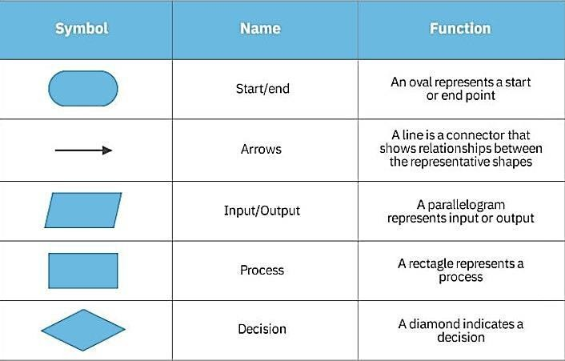

**Fig.4.1**: Flow Chart Symbols

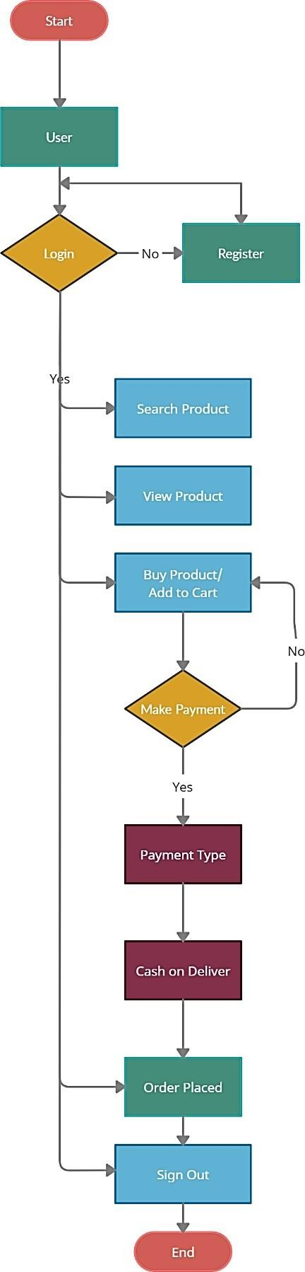

**Fig.4.2**: Flow Chart Diagram

## DATA FLOW CHART DIAGRAM

A Data Flow Diagram ) is a traditional visual representation of the information flows within a system. A neat and clear DFD can depict the right amount of the system requirement graphically. It can be manual, automated, or acombination of both.

It shows how data enters and leaves the system, what changes the information, and where data is stored.

The objective of a DFD is to show the scope and boundaries of a system as a whole. It may be used as a communication tool between a system analyst and anyperson who plays a part in the order that acts as a starting point for redesigning asystem. The DFD is also called as a data flow graph or bubble chart.

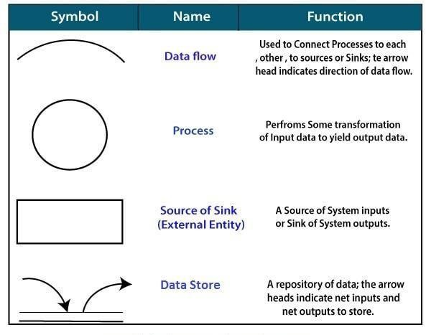

**Fig.4.3:** Data Flow Symbols

The DFD may be used to perform a system or software at any level of abstraction.In fact, DFDs may be partitioned into levels that represent increasing informationflow and functional detail. Levels in DFD are numbered 0, 1, 2 or beyond. Here, we will see primarily three levels in the data flow diagram, which are: 0-level DFD, 1-level DFD, and 2-level DFD.

## level DFD

The Level-0 DFD, also called context diagram of the result management system is shown in fig. As the bubbles are decomposed into less and less abstract bubbles,the corresponding data flow may also be needed to be decomposed.

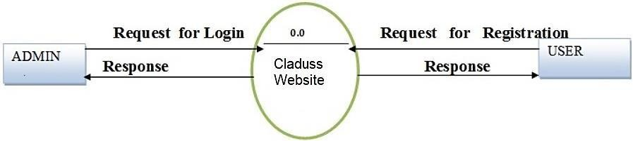

**Fig.4.4:** Level 0 DFD

## level DFD

In 1-level DFD, a context diagram is decomposed into multiple bubbles/processes.In this level, we highlight the main objectives of the system and breakdown the high-level process of 0-level DFD into subprocesses.

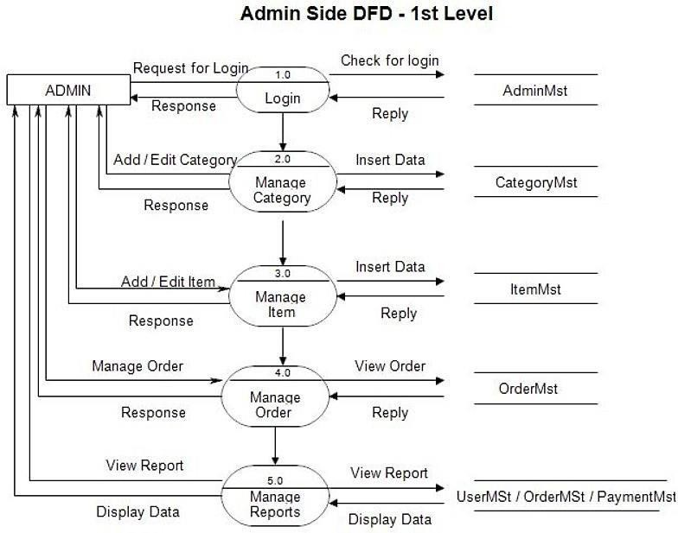

**Fig.4.5:** Level 1 DFD

## level DFD

2-level DFD goes one process deeper into parts of 1-level DFD. It can be used to project or record the specific/necessary detail about the system's functioning.

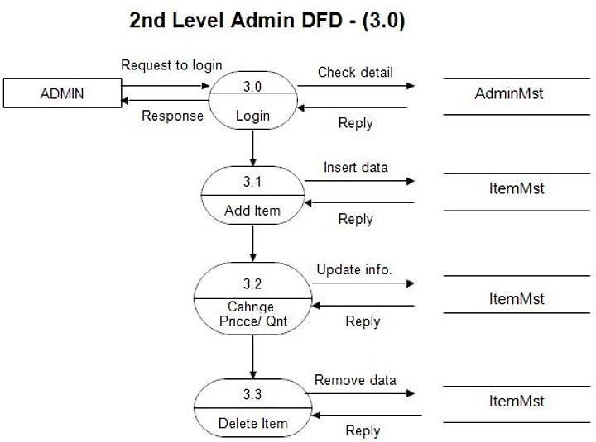

**Fig. 4.6(A):** Level 2 (3.0) DFD

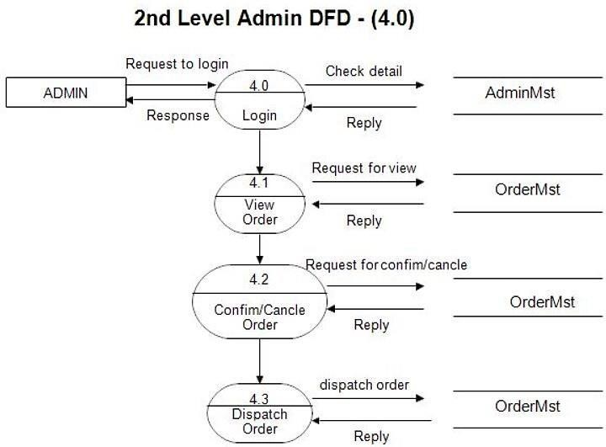

**Fig. 4.6(B):** Level 2(4.0) DFD

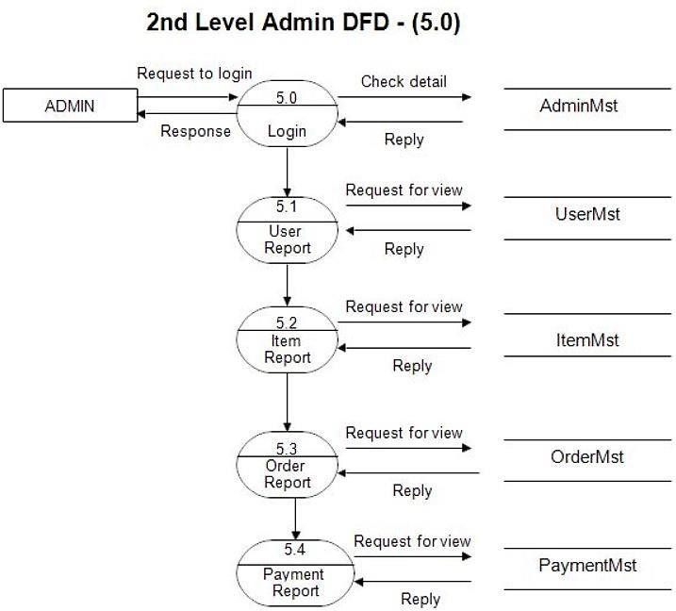

**Fig.4.6(C):** Level 2(5.0) DFD

## ENTITY RELATIONSHIP DIAGRAM

Entity-Relationship model stands for an ER model. It is a high-level data model. This model is used to define the data elements and relationship for a specified system.

It develops a conceptual design for the database. It also develops a very simpleand easy to design view of data.

In ER modeling, the database structure is portrayed as a diagram called an entity- relationship diagram.

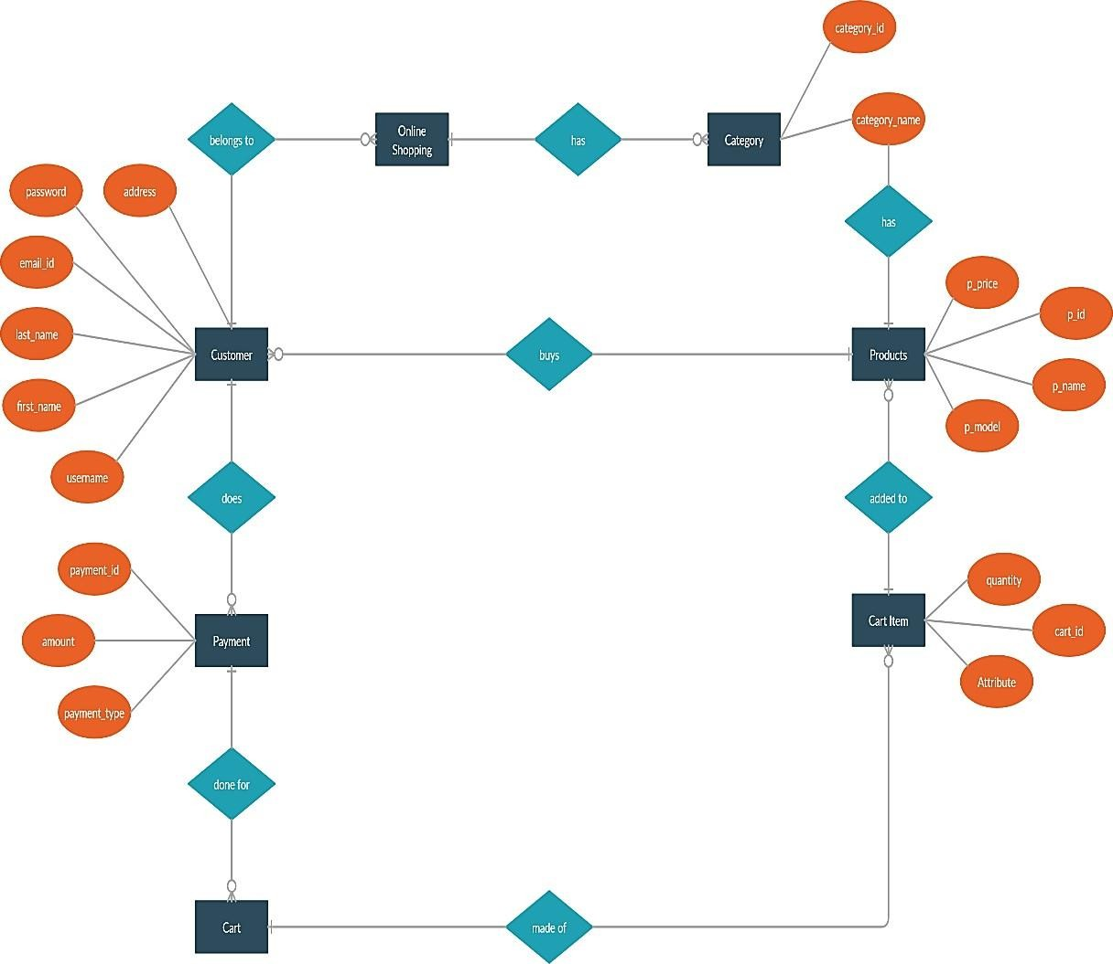

**Fig.4.7:** Entity Relationship Diagram

## USE CASE DIAGRAM

A use case diagram (UCD) is used to represent the dynamic behavior of asystem. It encapsulates the system's functionality by incorporating use cases, actors, and their relationships. It models the tasks, services, and functions required by a system/subsystem of an application. It depicts the high-level functionality ofa system and also tells how the user handles a system.

The main purpose of a use case diagram is to portray the dynamic aspect of a system. It accumulates the system's requirement, which includes both internal as well as external influences. It invokes persons, use cases, and several things that invoke the actors and elements accountable for the implementation of use case diagrams. It represents how an entity from the external environment can interact with a part of the system.

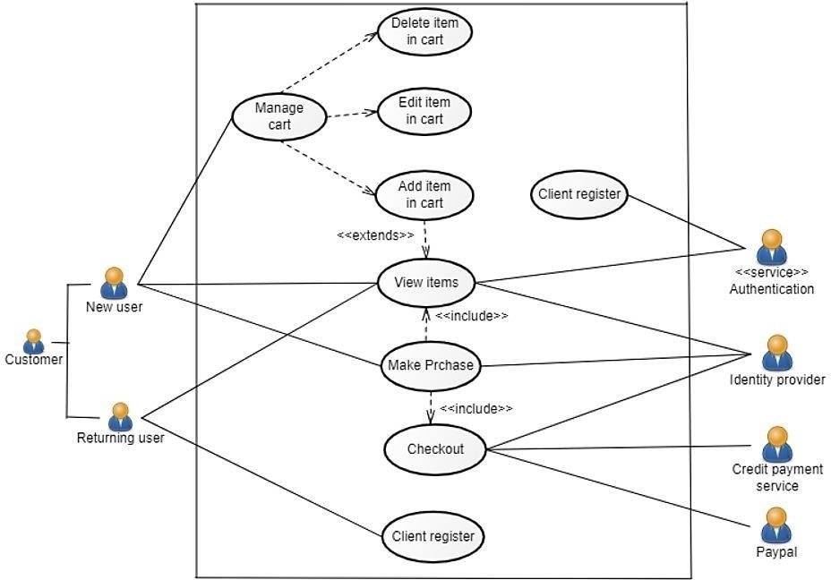

**Fig.4.8:** Use Case Diagram

## SEQUENCE DIAGRAM

The sequence diagram (SD) represents the flow of messages in the system and is also termed as an event diagram. It helps in envisioning several dynamic scenarios. It portrays the communication between any two lifelines as a time-ordered sequence of events, such that these lifelines took part at the run time.

In UML, the lifeline is represented by a vertical bar, whereas the message flow is represented by a vertical dotted line that extends across the bottom of the page. It incorporates the iterations as well as branching.

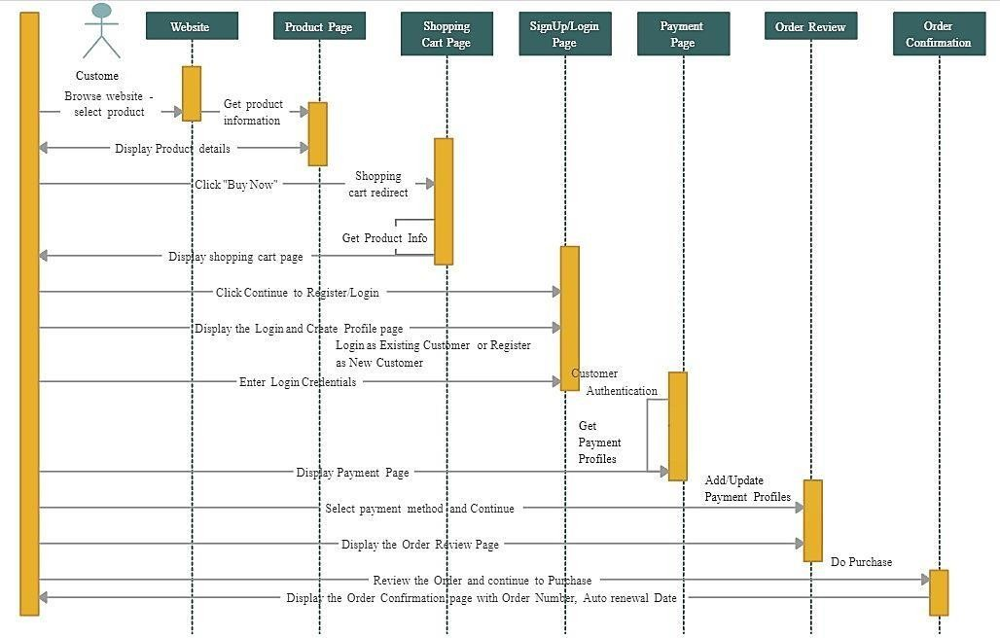

**Fig.4.9:** Sequence Diagram

**CHAPTER 5**

**FORM DESIGN**

## Landing Page

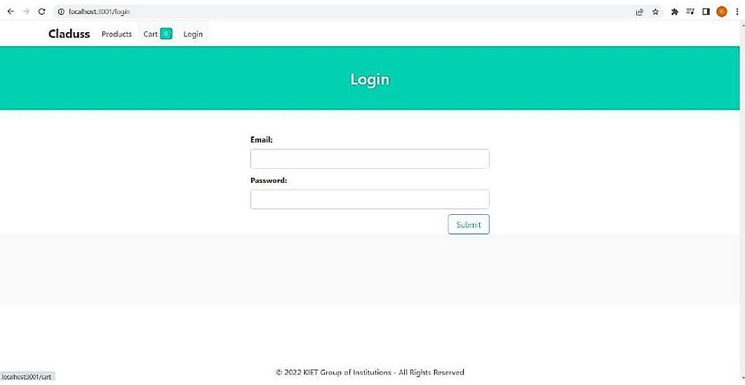

**Fig.5.1:** Landing Page

## Login Page

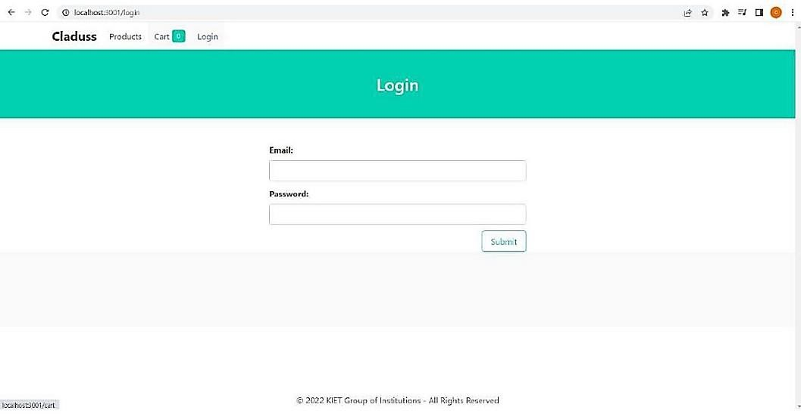

**Fig.5.2:** Login Page

## Products Page

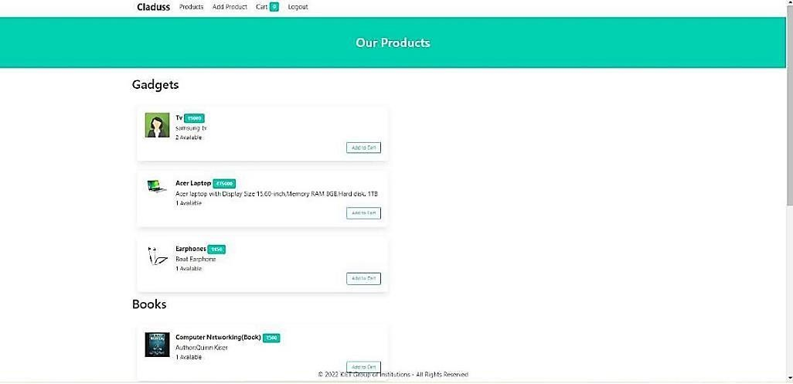

**Fig.5.3:** Product Page

## Add Product Page

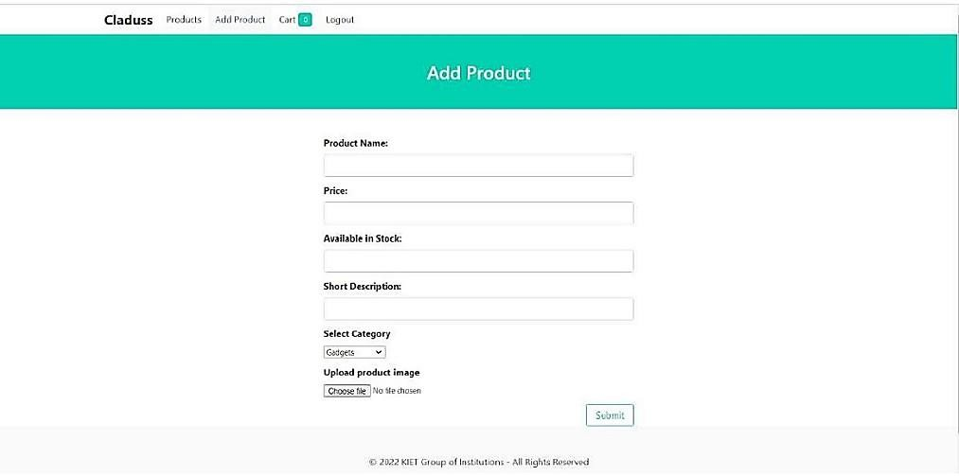

**Fig.5.4:** Add Product Page

## Cart Page

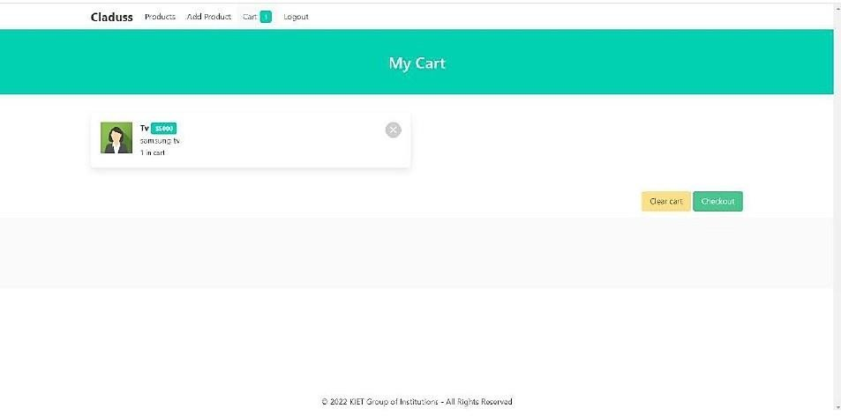

**Fig.5.5:** Cart Page

**CHAPTER 6**

**Testing**

## Login

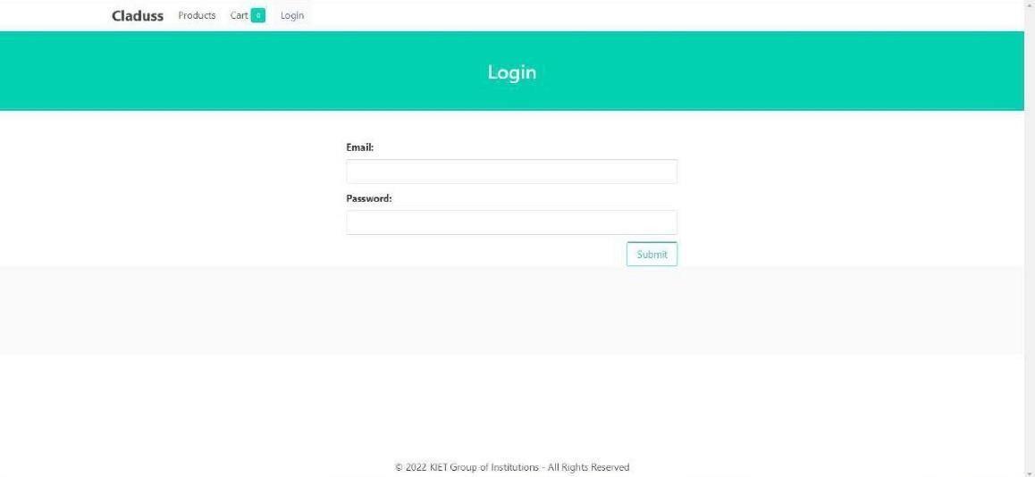

**Fig.6.1:** Login Page Interface

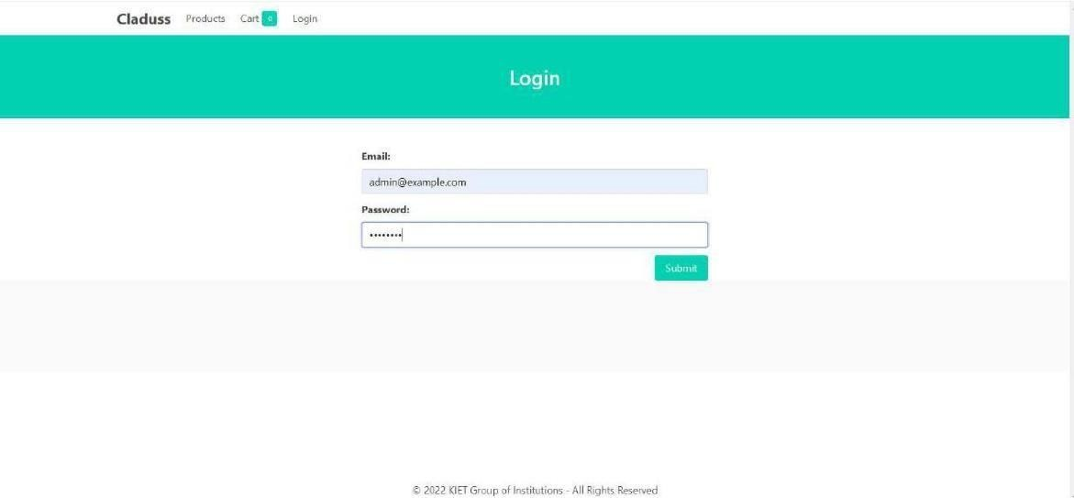

**Fig. 6.2:** Login Page Authentication

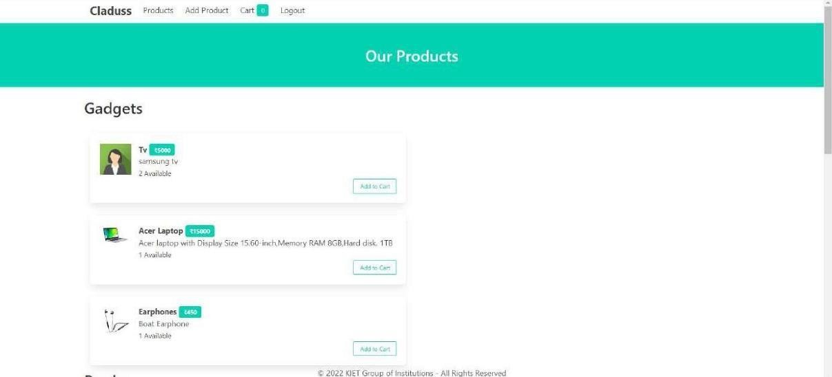

**Fig.6.3**: Login Page Verified User

## Add Products

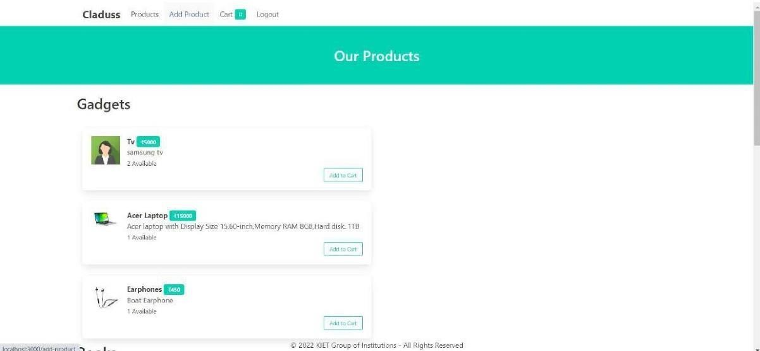

**Fig.6.4:** Product Page Interface

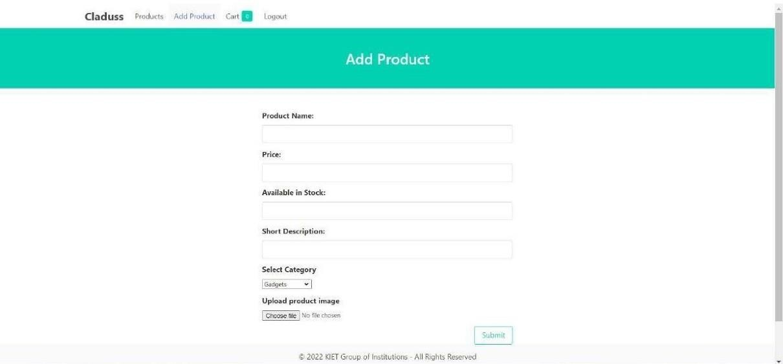

**Fig.6.5:** Add Product Page Interface

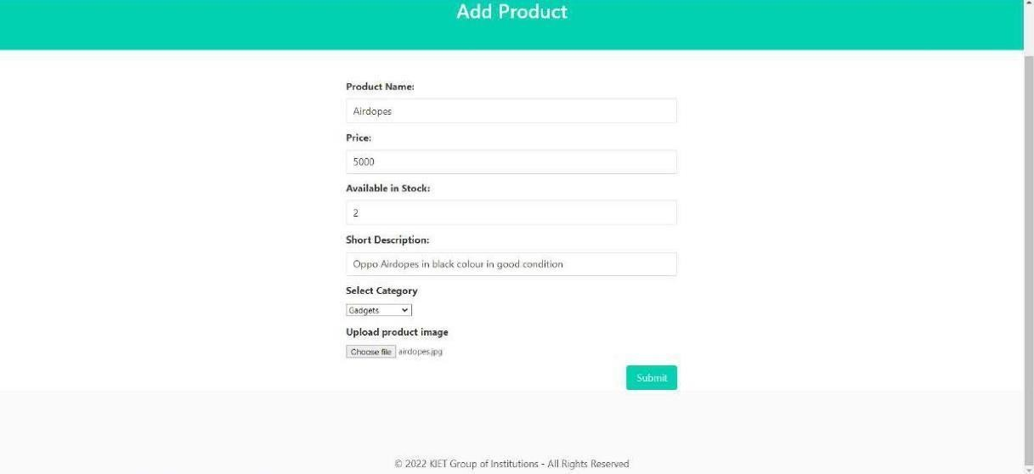

**Fig.6.6:** Product Adding Page Interface

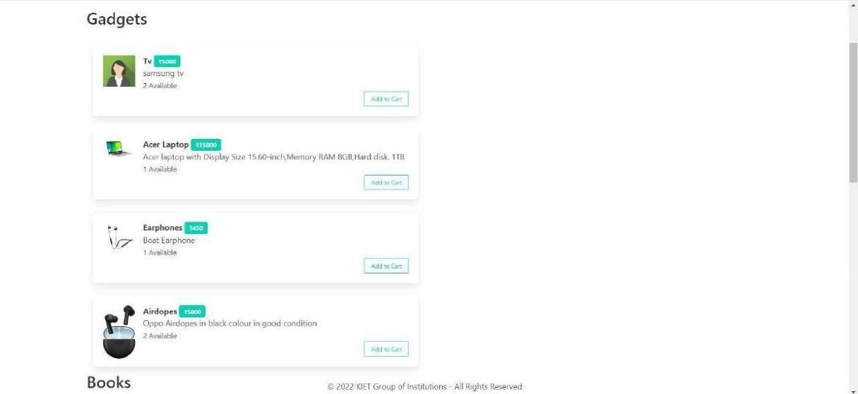

**Fig.6.7:** Product Added Successfully Page

## Cart

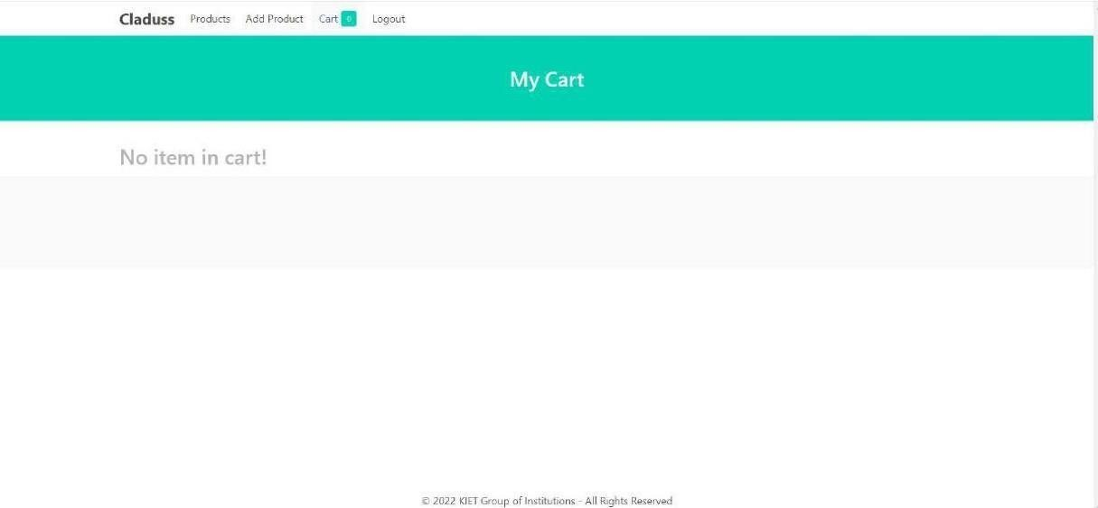

**Fig. 6.8:** Cart Page Interface

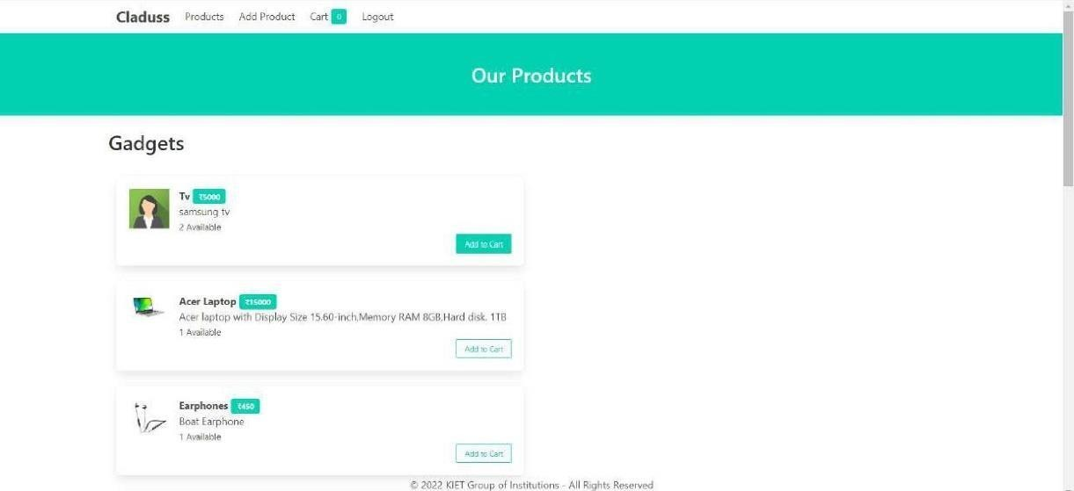

**Fig.6.9:** Adding Products to Cart Page Interface

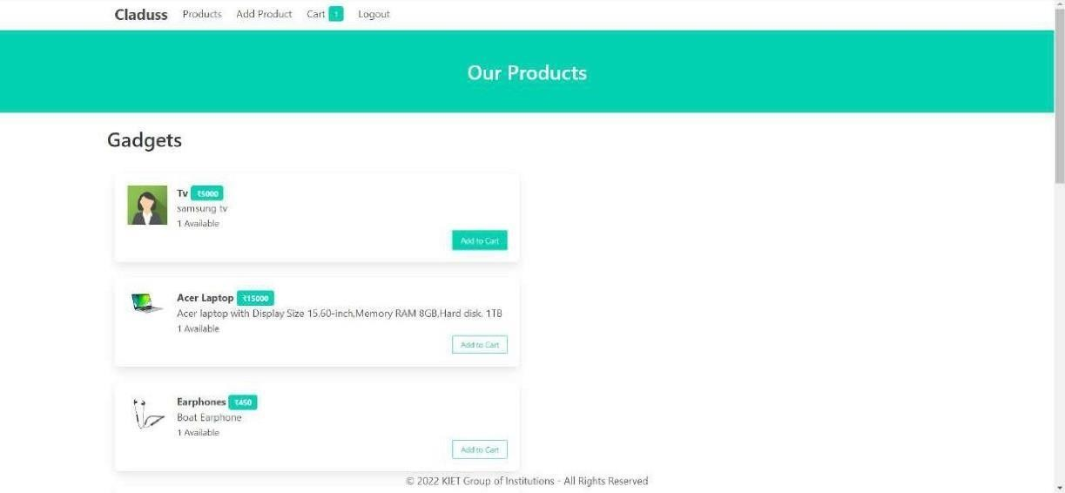

**Fig.6.10:** T.V. Added Successfully Page Interface

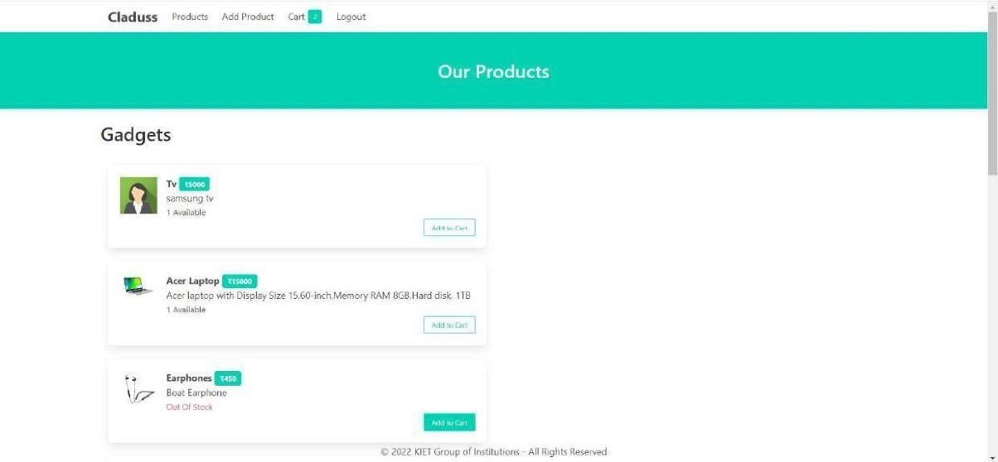

**Fig.6.11:** Earphone Added Successfully Page Interface

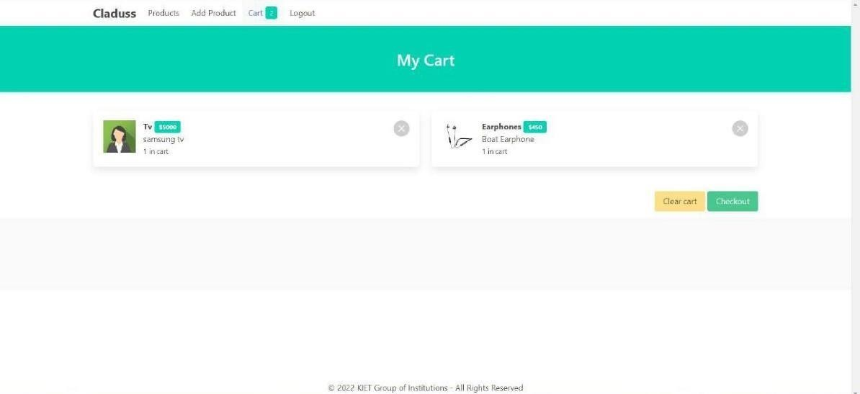

**Fig.6.12:** T.V. and Earphone Added to Cart Page Interface

## Placed /Modify

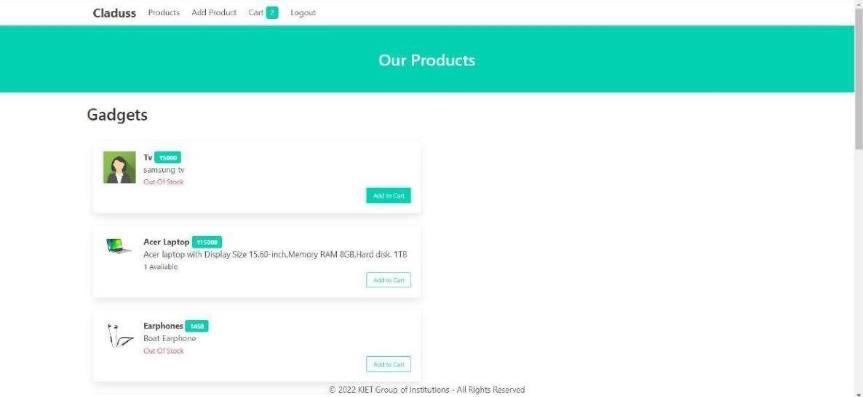

**Fig.6.13:** Adding 1 more T.V. to Cart Page Interface



**Fig.6.14:** Adding 1 more Earphone to Cart Page Interface

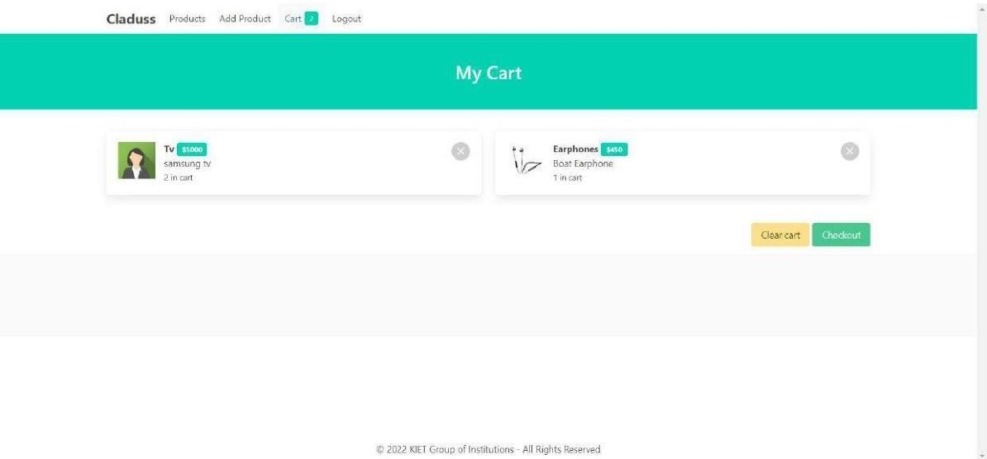

**Fig.6.15:** Product Modifications Successfully Page Interface

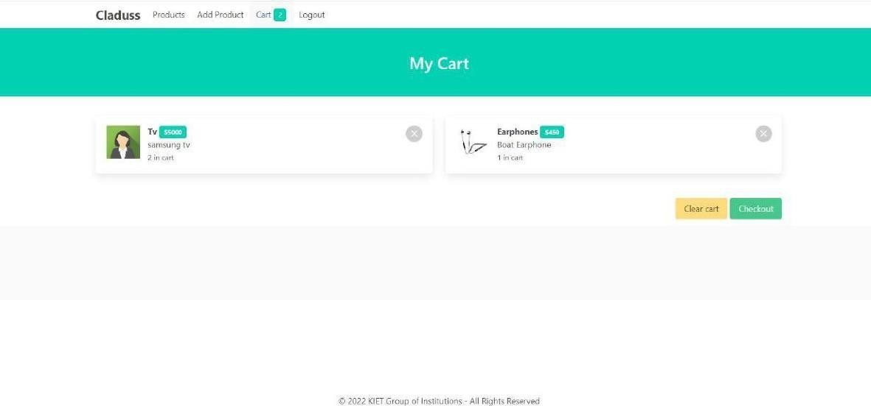

**Fig.6.16:** Products Removing Page Interface

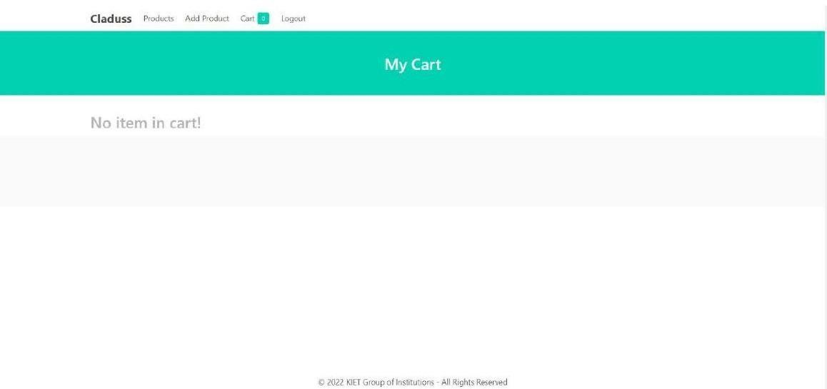

**Fig.6.17:** Products Removed successful Page Interface

## Logout



**Fig.6.18:** Logout Successful Page Interface

**CHAPTER 7**

**Bibliography**

* + 1. C# 8.0 and .NET Core 3.0 – Modern Cross-Platform Development: Build applications with C#, .NET Core, Entity Framework Core, ASP.NET Core, and ML.NET using Visual Studio Code, 4th Edition
    2. C. J. Date, A. Kannan and S. Swamynathan, *An Introduction to Database Systems*, Pearson Education, Eighth Edition, 2009.
    3. Abraham Silberschatz, Henry F. Korth and S. Sudarshan, *Database System*

*Concepts*, McGraw-Hill Education (Asia), Fifth Edition, 2006.

* + 1. Pressmen, Somerville, Software Engineering: Design, Implementation, and Management.

Applications

* [www.google.com](http://www.google.com/)
* [www.stackoverflow.com](http://www.stackoverflow.com/)
* [www.w3schools.com](http://www.w3schools.com/)
* [www.coderoject.com](http://www.coderoject.com/)